23CSE202 DATABASE MANAGEMENT SYSTEMS
S3 B.Tech CSE
Department of Computer Science and Engineering
Amrita School of Computing, Amritapuri Campus

PROJECT REPORT

Group No : D2
Team Members :
Roll No | Student Name
AM.SC.U4CSE25304 | Avinash Menon
AM.SC.U4CSE25306 | Arav D A
AM.SC.U4CSE25310 | Boomish Saravanan
AM.SC.U4CSE25311 | Chevuru Neekshitha

Project Title : FinTrack – Personal Finance Management System

CONTENTS
Sl. No | Chapter | Page No
1 | Abstract
2 | Introduction
3 | Requirements (Functional & Non-functional)
4 | UI Design
5 | Database Design
6 | Database Selection & Justification
7 | Implementation
8 | Testing & Validation
9 | Results & Screenshots
10 | Challenges faced & solutions
11 | Conclusion & future enhancements
 | References

1 Abstract:
Managing personal finances has become increasingly challenging for students and young professionals due to the growing number of daily financial transactions. Many individuals either rely on manual record-keeping or use applications with unnecessary complexity, making it difficult to effectively monitor income, expenses, budgets, and savings. This often leads to poor financial planning, overspending, and limited awareness of spending patterns. To address these challenges, this project proposes *FinTrack – Personal Finance Management System*, a database-driven web application that provides a centralized platform for efficient financial management.

The primary objective of FinTrack is to help users securely manage their personal finances by recording income and expenses, organizing transactions into customizable categories, setting monthly budgets, tracking savings goals, and generating financial reports. The system aims to provide users with meaningful insights into their financial habits through summaries and analytics while maintaining data integrity and security.

The proposed system is developed using *Python (Flask)* as the backend framework and *PostgreSQL* as the relational database management system. PostgreSQL is used to efficiently manage interconnected entities such as users, accounts, income records, expense transactions, categories, budgets, savings goals, notifications, and reports. The database is designed using proper normalization techniques up to Third Normal Form (3NF) to eliminate redundancy and maintain consistency. The system also incorporates primary and foreign key constraints, views, aggregate queries, joins, and database triggers to support advanced operations beyond basic create, read, update, and delete functionalities.

The intended users of the system include students, working professionals, and individuals who wish to maintain a structured record of their personal finances. An administrative module is also included to manage system categories and monitor application data.

The major functionalities of FinTrack include user registration and authentication, income and expense management, category-based transaction organization, monthly budget allocation, savings goal tracking, transaction filtering, financial report generation, and dashboard-based spending analysis. By integrating robust database design with practical financial management features, the proposed system demonstrates the effective application of Database Management System concepts while providing a scalable and user-friendly solution for personal finance management.

2 Introduction:
2.1 Background
Personal financial management is an important part of everyday life. Individuals regularly receive income, make payments, manage multiple financial accounts, and save money for future needs. Keeping track of these activities helps people understand their spending habits, control unnecessary expenses, and plan their finances effectively. However, when financial information is maintained in separate places, it becomes difficult to obtain a clear picture of one's overall financial situation.
Many individuals rely on notebooks, spreadsheets, or banking applications to monitor their income and expenses. Although these methods are useful for basic record-keeping, they may not provide a centralized solution for managing transactions, categorizing expenses, setting budgets, and tracking savings goals together. As the amount of financial information increases, manually maintaining records can become time-consuming and may lead to errors or incomplete information.
2.2 Problem Statement
The main problem addressed by this project is the difficulty of maintaining and monitoring personal financial information in an organized and consistent manner. Users need a system that allows them to record income and expenses, manage different accounts, categorize transactions, monitor budget utilization, and track progress toward savings goals.
When these activities are handled independently, users may find it difficult to calculate their total income and expenses, identify major spending categories, determine how much of a budget remains, or evaluate their progress toward financial targets. There is therefore a need for a database-driven application that stores financial records systematically and provides useful information through a simple user interface.
2.3 Existing System and Its Limitations
In the existing scenario, personal financial records are often maintained using manual methods, spreadsheets, or separate financial applications. Manual record-keeping requires users to update and calculate their financial information themselves. Spreadsheets provide greater flexibility but may require additional formulas and maintenance to generate useful summaries. Using multiple applications can also make it difficult to maintain a unified view of financial activities.
The major limitations of these approaches include:
- Scattered information: Financial records may be stored in different places instead of one centralized system.
- Manual calculations: Calculating income, expenses, account balances, and remaining budgets can require additional effort.
- Limited budget monitoring: Comparing actual expenses against allocated budgets may not be straightforward.
- Difficulty tracking savings: Users may not have a single view of their savings targets and progress.
- Data inconsistency: Manually maintained records can contain duplicate, incomplete, or inconsistent information.
- Limited integration: Accounts, transactions, budgets, categories, and savings goals may not be connected through a common data model.
These limitations highlight the need for a structured system that integrates the different aspects of personal financial management.
2.4 Proposed System
Fintrack is a personal finance management application designed to address these limitations through a centralized relational database. It uses PostgreSQL to store and manage user information, financial accounts, categories, transactions, budgets, and savings goals. The application provides a web-based interface through which users can interact with their financial records.
The system includes user registration and login, account management, income and expense tracking, transaction categorization, budget allocation, and savings goal management. Users can record financial transactions and organize them according to their categories and accounts. Budget information can be used to compare allocated amounts with actual expenses and calculate the remaining budget. Savings goals allow users to define financial targets and monitor the amount saved toward each target.
The backend is developed using Python and Flask, which processes application requests and communicates with the PostgreSQL database. The frontend uses HTML, CSS, and JavaScript to provide the user interface and interact with the backend. Database constraints and relationships help maintain consistency between related records, while SQL queries retrieve and summarize financial information.
2.5 Objectives
The main objectives of Fintrack are:
- To develop a centralized application for managing personal financial information.
- To maintain financial records using a relational database with appropriate keys, relationships, and constraints.
- To support the creation and management of financial accounts, income records, and expense records.
- To organize transactions using categories and provide useful spending summaries.
- To support budget creation and comparison of allocated amounts against actual expenses.
- To enable users to create savings goals and monitor their progress.
- To apply database management concepts such as ER modelling, relational schema design, normalization, SQL queries, and CRUD operations in a practical application.
2.6 Scope of the Project
The scope of Fintrack is limited to personal financial record management. It focuses on storing and retrieving financial data, organizing transactions, monitoring budgets, and tracking savings goals through a web interface. The project demonstrates how a relational database can support the consistent management of related financial information and how a backend application can make that information accessible to users.
Fintrack is intended as an academic database application and does not directly connect to bank accounts or automatically retrieve transactions from financial institutions. Its effectiveness depends on users entering and maintaining accurate financial records.

3. REQUIREMENTS
The requirements of Fintrack define the operations supported by the application and the quality attributes expected from the system. They are divided into functional and non-functional requirements.
3.1 Functional Requirements
The functional requirements specify the main operations performed by the system.
- User Authentication: The system shall allow users to register, log in, and log out using their credentials.
- Account Management: The system shall allow users to create and manage financial accounts, such as bank, cash, savings, and credit accounts.
- Transaction Management: The system shall support adding, viewing, updating, and deleting income and expense transactions.
- Category Management: The system shall allow transactions to be organized into categories, such as food, entertainment, and transport.
- Budget Management: The system shall allow users to create budgets, allocate amounts to categories, and monitor spending against allocated amounts.
- Savings Goal Management: The system shall allow users to create savings goals, specify target amounts, and monitor savings progress.
- Financial Summary: The system shall retrieve and display relevant financial summaries, including account balances, income, expenses, and budget utilization.
- Data Storage and Retrieval: The system shall store financial information in PostgreSQL and retrieve records using appropriate SQL queries.
- Data Integrity: The system shall maintain relationships between records using primary keys, foreign keys, uniqueness constraints, and other applicable database constraints.
3.2 Non-functional Requirements
The non-functional requirements describe the expected quality and operational characteristics of the system.
- Performance: The system should retrieve and display financial records within a reasonable time for normal usage.
- Security: The system should protect user credentials using password hashing and restrict access to user-specific financial information.
- Reliability: The system should store and retrieve records consistently and handle invalid inputs or database errors appropriately.
- Usability: The interface should be simple and understandable, allowing users to navigate between accounts, transactions, budgets, and savings goals.
- Data Integrity: The database should prevent invalid references and maintain consistency between related records.
- Maintainability: The application should separate the frontend, backend, and database components to simplify debugging and future modifications.
- Scalability: The database design should support the addition of more users and financial records without requiring a complete redesign.
These requirements guide the design, implementation, and testing of Fintrack as a database-driven personal finance management application.

4. UI DESIGN
4.1 Introduction
The user interface of Fintrack is designed to provide a simple and convenient way to manage personal financial information. It allows users to interact with the application through web pages without directly accessing the database or writing SQL queries. The interface communicates with the Flask backend, which processes user requests and retrieves or updates information stored in the PostgreSQL database.
The interface is organized into different sections for account management, transaction tracking, category management, budget monitoring, and savings goal management. This organization allows users to access the required features easily.
4.2 Login and Registration Screen
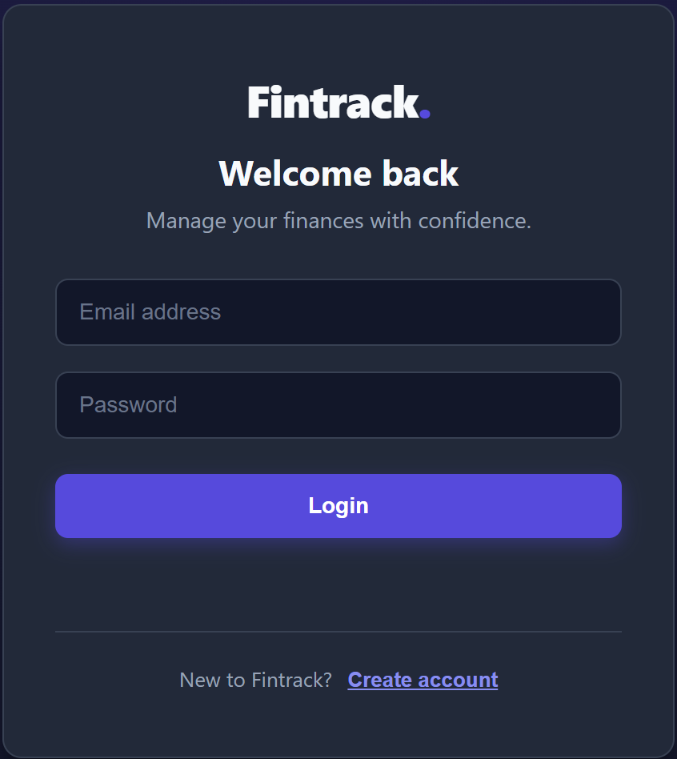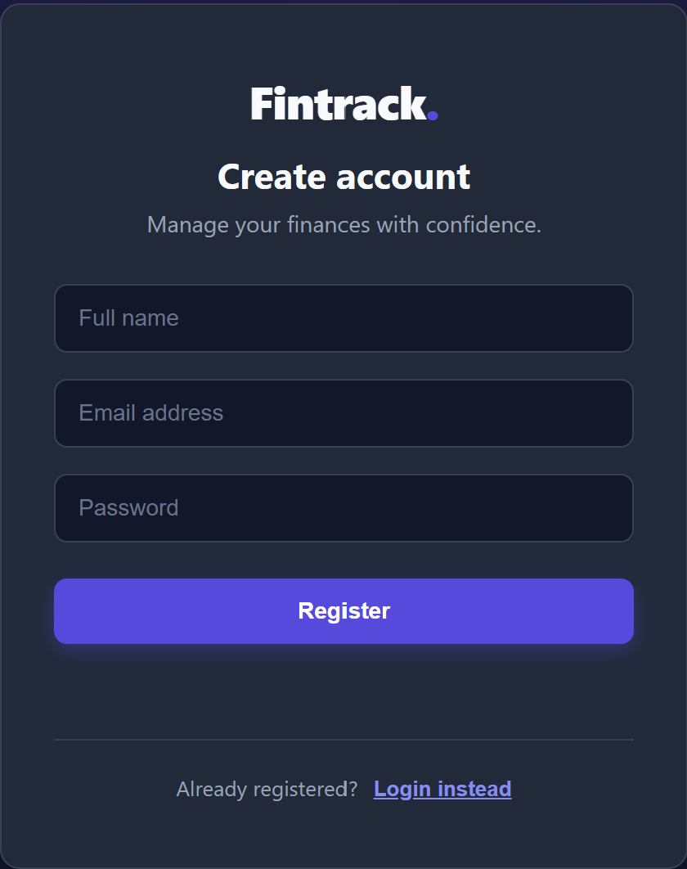

4.3 Dashboard
The dashboard provides an overview of the user's financial information. It displays relevant summaries, such as total account balance, income, expenses, and budget information, depending on the features implemented in the application.
The dashboard helps users understand their financial position without manually examining individual database records. Users can navigate to other sections of the application to view more detailed information or manage their financial records.

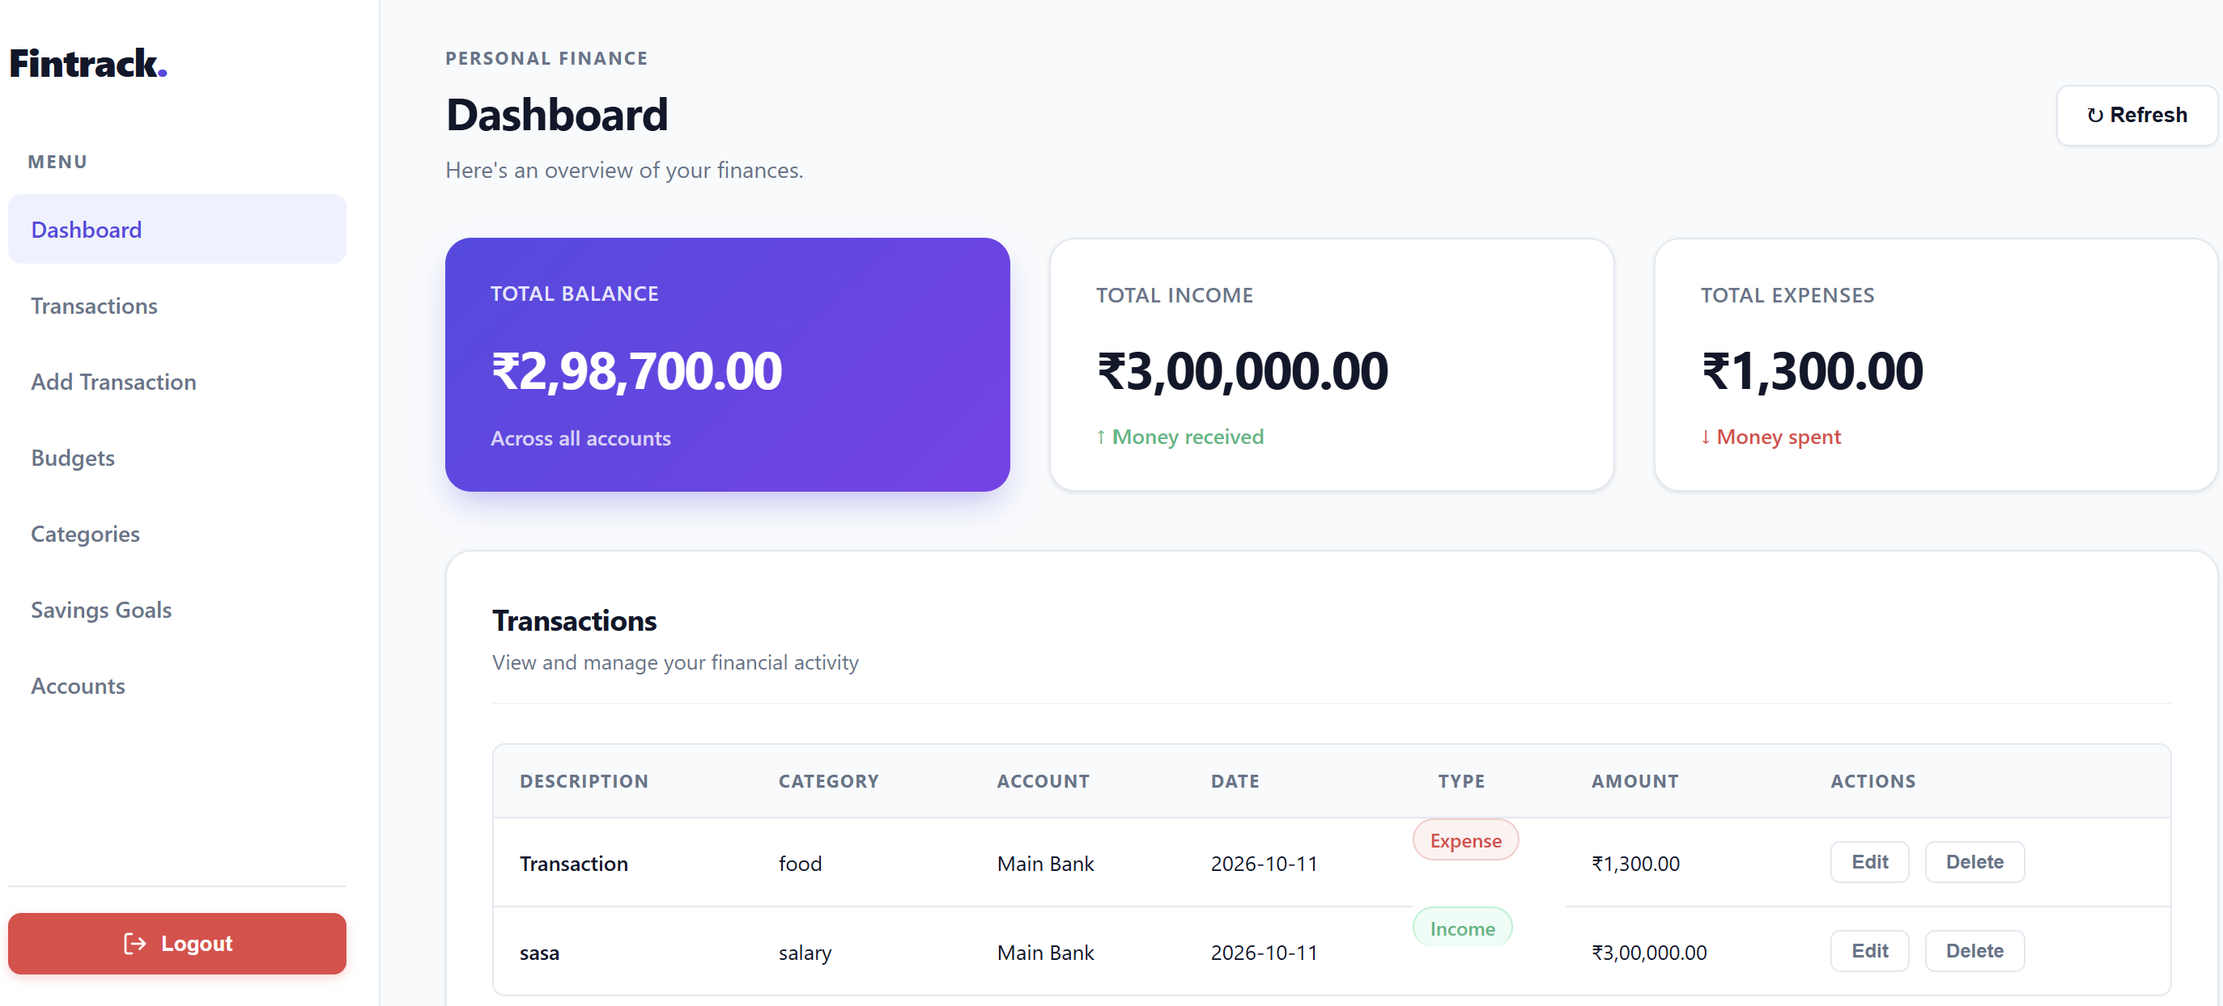
4.4 Account and Transaction Management
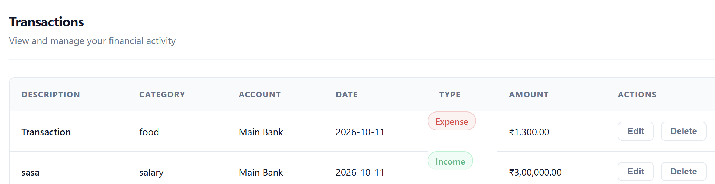
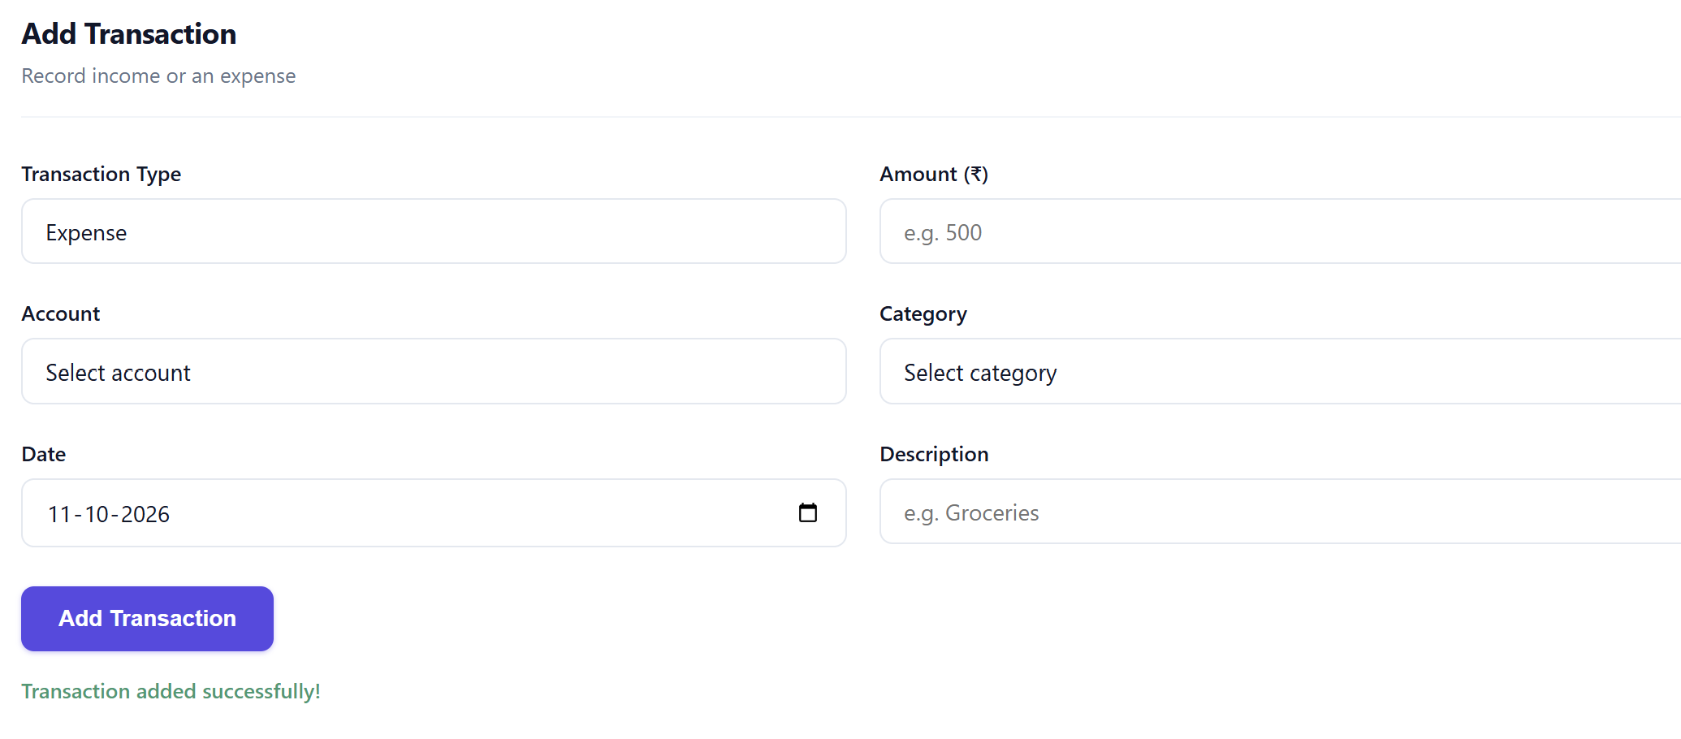

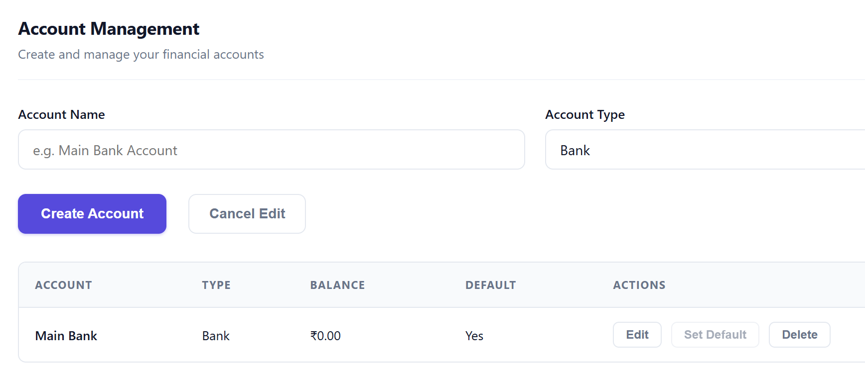

4.5 Category and Budget Management
The category section allows users to organize transactions into meaningful groups, such as food, entertainment, and transport. Categories help users classify their spending and support category-based budget calculations.
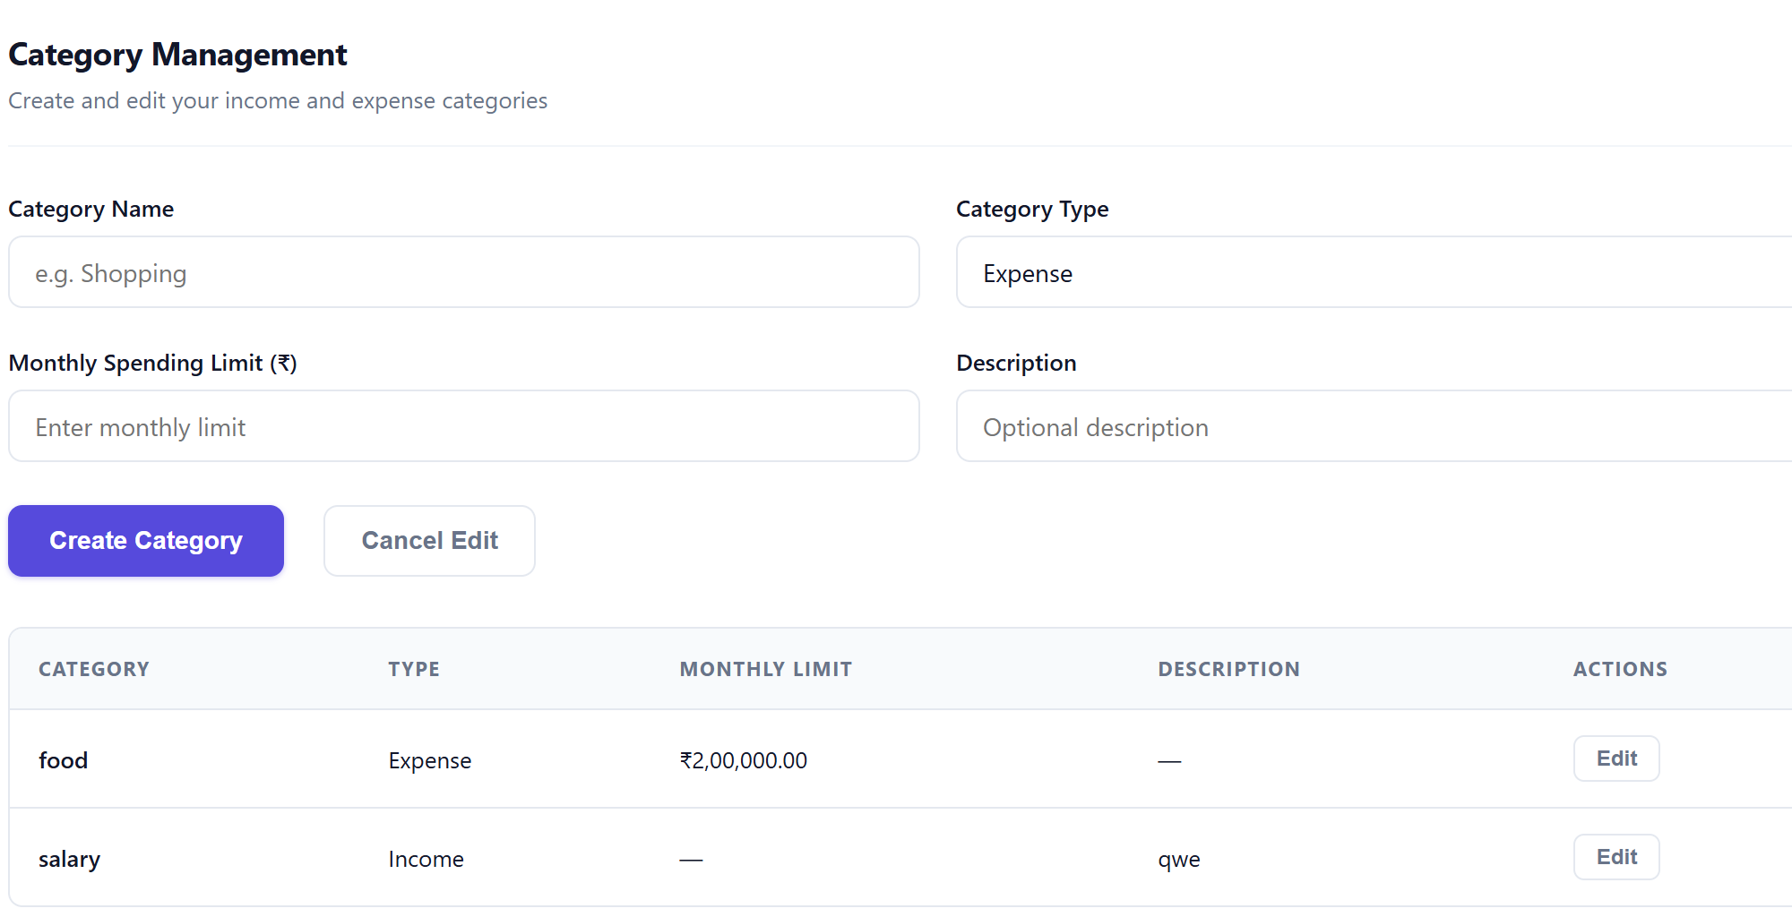

4.6 Savings Goal Management
The savings goal section allows users to define financial targets by specifying details such as the goal name, target amount, and target date. The application displays the saved amount and progress toward the target when these values are available
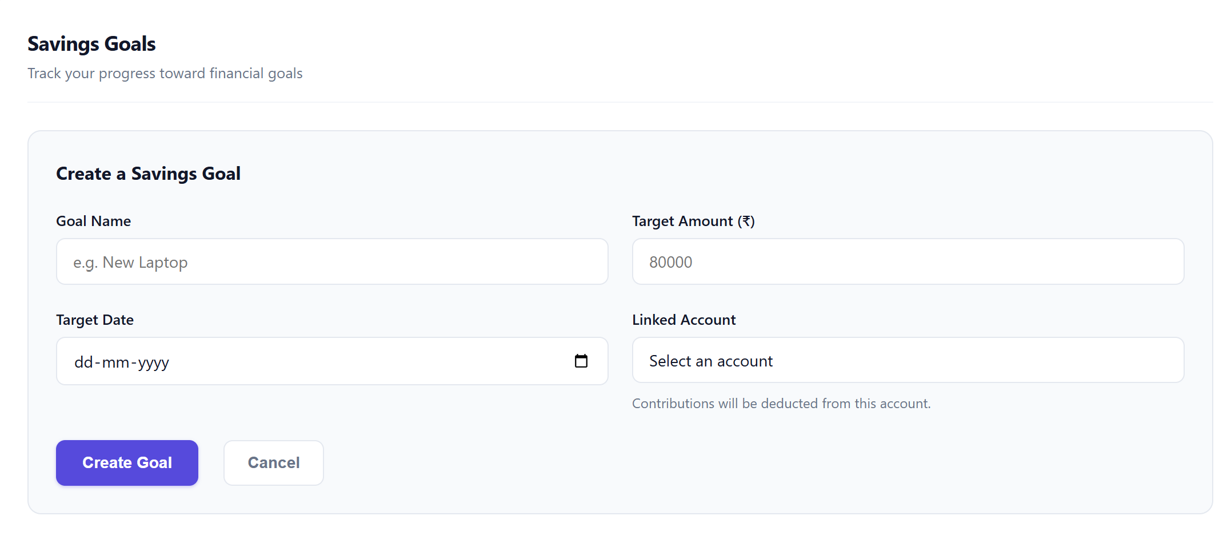
5. DATABASE DESIGN
5.1 Overview
The database design of Fintrack is based on a relational database model implemented using PostgreSQL. The database stores user details and the financial information associated with each user. The design consists of seven tables: users, accounts, categories, transactions, budgets, budget_category, and savings_goals.
The tables are connected through primary keys and foreign keys to maintain relationships between related records. Integrity constraints are used to prevent invalid data and improve consistency. The budget_category table acts as a junction table to represent the many-to-many relationship between budgets and categories.
5.2 Entity–Relationship Diagram
The Entity–Relationship (ER) diagram represents the entities in Fintrack, their attributes, and the relationships between them. It serves as the foundation for converting the conceptual database model into relational tables.
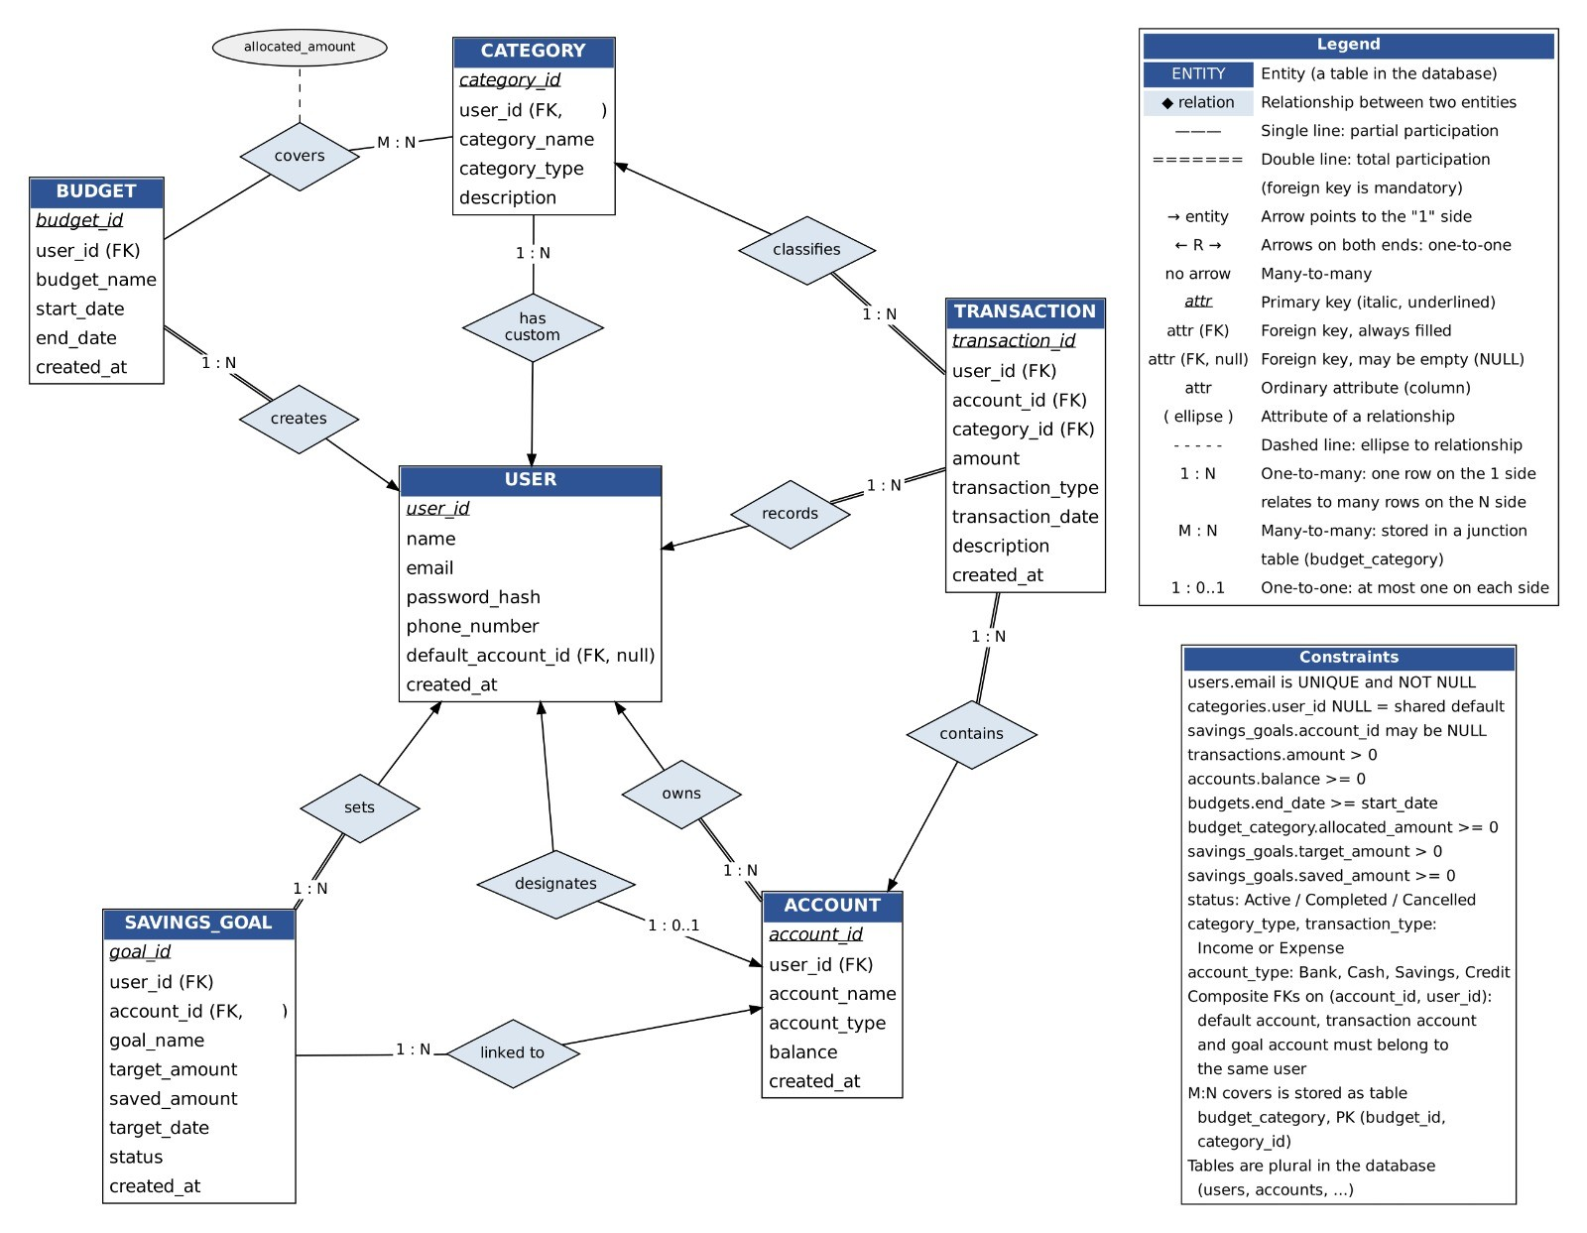
The ER diagram contains seven relational tables, including the junction table used for budget allocation. It represents the relationships among users, accounts, categories, transactions, budgets, and savings goals.
5.3 Entities and Attributes
The database contains the following tables.
1. Users
The users table stores the details of registered users.
- user_id – Primary key that uniquely identifies each user.
- name – Name of the user.
- email – Email address, which must be unique.
- password_hash – Hashed password used for authentication.
- phone_number – Contact number.
- default_account_id – Optional reference to the user's default account.
- created_at – Timestamp indicating when the user record was created.
2. Accounts
The accounts table stores the financial accounts belonging to users.
- account_id – Primary key.
- user_id – Foreign key referencing users.
- account_name – Name of the account.
- account_type – Type of account, such as bank, cash, savings, or credit.
- balance – Account balance.
- created_at – Account creation timestamp.
3. Categories
The categories table stores the categories used to classify financial transactions.
- category_id – Primary key.
- user_id – Optional foreign key referencing users; a NULL value represents a shared system category.
- category_name – Name of the category.
- category_type – Indicates whether the category is for income or expenses.
- description – Additional information about the category.
4. Transactions
The transactions table records financial activities.
- transaction_id – Primary key.
- user_id – Foreign key referencing users.
- account_id – Foreign key referencing accounts.
- category_id – Foreign key referencing categories.
- amount – Transaction amount.
- transaction_type – Income or expense.
- transaction_date – Date of the transaction.
- description – Details of the transaction.
- created_at – Timestamp indicating when the record was created.
5. Budgets
The budgets table stores budget information created by users.
- budget_id – Primary key.
- user_id – Foreign key referencing users.
- budget_name – Name of the budget.
- start_date – Starting date of the budget period.
- end_date – Ending date of the budget period.
- created_at – Budget creation timestamp.
6. Budget_Category
The budget_category table connects budgets with categories and stores the allocated amount for each category within a budget.
- budget_id – Foreign key referencing budgets.
- category_id – Foreign key referencing categories.
- allocated_amount – Amount allocated to the corresponding category.
The combination of budget_id and category_id forms the composite primary key.
7. Savings_Goals
The savings_goals table stores the savings targets defined by users.
- goal_id – Primary key.
- user_id – Foreign key referencing users.
- account_id – Optional foreign key referencing accounts.
- goal_name – Name of the savings goal.
- target_amount – Amount the user aims to save.
- saved_amount – Amount saved toward the goal.
- target_date – Target date for achieving the goal.
- status – Current status of the goal.
5.4 Relationships and Cardinalities
The relationships between the entities are described below.
Relationship | Cardinality | Description
Users–Accounts | One-to-many (1) | A user can own multiple accounts.
Users–Categories | One-to-many (1), with optional ownership | A user can create categories; shared categories may have no individual owner.
Users–Transactions | One-to-many (1) | A user can record multiple transactions.
Users–Budgets | One-to-many (1) | A user can create multiple budgets.
Users–Savings_Goals | One-to-many (1) | A user can create multiple savings goals.
Accounts–Transactions | One-to-many (1) | An account can be associated with multiple transactions.
Categories–Transactions | One-to-many (1) | A category can classify multiple transactions.
Budgets–Categories | Many-to-many (M) | A budget can include multiple categories, and a category can appear in multiple budgets.
Accounts–Savings_Goals | One-to-many (1), optional for a goal | An account can be linked to multiple savings goals; a goal may have no linked account.
The many-to-many relationship between budgets and categories is implemented using the budget_category junction table. The optional default_account_id in users also allows a user to designate one of their accounts as the default account.
5.5 Primary Keys, Foreign Keys, and Constraints
Primary keys uniquely identify records in each table. Foreign keys connect related tables and ensure that references point to existing records.
The main constraints used in the database include:
- Primary key constraints: Ensure that every record has a unique identifier.
- Foreign key constraints: Maintain valid relationships between users, accounts, transactions, budgets, categories, and savings goals.
- Unique constraints: Prevent duplicate email addresses and duplicate account names for the same owner, where specified in the schema.
- NOT NULL constraints: Ensure that required attributes contain values.
- CHECK constraints: Validate values such as positive transaction amounts, non-negative account balances and allocations, valid transaction types, valid budget dates, and permitted savings-goal statuses.
- Default values: Provide predefined values for applicable attributes, such as record creation timestamps.
- Composite primary key: The combination of budget_id and category_id prevents the same category from being assigned more than once to the same budget.
These constraints help preserve data integrity and reduce invalid or inconsistent records.
5.6 Relational Schema
The ER model is represented in the following relational schema. Primary keys are marked as PK and foreign keys as FK.
- USERS(user_id PK, name, email UNIQUE, password_hash, phone_number, default_account_id FK, created_at)
- ACCOUNTS(account_id PK, user_id FK, account_name, account_type, balance, created_at)
- CATEGORIES(category_id PK, user_id FK, category_name, category_type, description)
- TRANSACTIONS(transaction_id PK, user_id FK, account_id FK, category_id FK, amount, transaction_type, transaction_date, description, created_at)
- BUDGETS(budget_id PK, user_id FK, budget_name, start_date, end_date, created_at)
- BUDGET_CATEGORY(budget_id PK/FK, category_id PK/FK, allocated_amount)
- SAVINGS_GOALS(goal_id PK, user_id FK, account_id FK, goal_name, target_amount, saved_amount, target_date, status)
The actual PostgreSQL schema defines the detailed data types, nullability rules, constraint names, and referential actions for these relations.
5.7 Conversion of ER Model into Relational Tables
The ER model was converted into relational tables using standard ER-to-relational mapping rules.
- Strong entities: Each independent entity, such as Users, Accounts, Categories, Transactions, Budgets, and Savings_Goals, was mapped to a separate relational table. Each table has a primary key.
- One-to-many relationships: Foreign keys were placed on the many side of each relationship. For example, user_id is included in accounts because one user can own multiple accounts.
- Many-to-many relationships: The relationship between Budgets and Categories was converted into the budget_category junction table. The primary key is formed by the combination of budget_id and category_id.
- Optional relationships: Optional associations, such as the default account of a user and the account linked to a savings goal, are represented using nullable foreign-key attributes.
- Integrity constraints: Primary keys, foreign keys, uniqueness rules, and check constraints were defined to preserve the validity of the stored data.
This conversion produces a relational structure that can be implemented and queried using SQL in PostgreSQL.
5.8 Functional Dependencies
A functional dependency describes a relationship in which the value of one attribute or a set of attributes determines the value of another attribute or set of attributes.
The main functional dependencies in Fintrack are:
- Users: user_id → name, email, password_hash, phone_number, default_account_id, created_at
- Accounts: account_id → user_id, account_name, account_type, balance, created_at
- Categories: category_id → user_id, category_name, category_type, description
- Transactions: transaction_id → user_id, account_id, category_id, amount, transaction_type, transaction_date, description, created_at
- Budgets: budget_id → user_id, budget_name, start_date, end_date, created_at
- Budget_Category: (budget_id, category_id) → allocated_amount
- Savings_Goals: goal_id → user_id, account_id, goal_name, target_amount, saved_amount, target_date, status
In addition, email uniquely identifies a user because it is subject to a UNIQUE constraint. Any other candidate keys depend on the additional uniqueness constraints defined in the schema.
These dependencies help identify keys and determine whether attributes are stored in the appropriate relations.
5.9 Normalization
Normalization is the process of organizing relational tables to reduce unnecessary redundancy and prevent insertion, update, and deletion anomalies.
First Normal Form (1NF)
A relation is in First Normal Form when each attribute contains a single, atomic value and there are no repeating groups. In Fintrack, account details, transaction details, budget details, and savings-goal details are stored as individual records. Multiple categories associated with a budget are stored as separate rows in budget_category instead of being stored as a list in a single column.
Second Normal Form (2NF)
A relation is in Second Normal Form when it is in 1NF and every non-key attribute depends on the whole candidate key rather than only part of a composite key. In budget_category, allocated_amount depends on the combination of budget_id and category_id, not on either attribute independently. The other tables use single-column primary keys, so they do not have partial dependencies on a composite primary key.
Third Normal Form (3NF)
A relation is in Third Normal Form when it is in 2NF and has no non-key attribute that depends transitively on a candidate key through another non-key attribute. Fintrack separates users, accounts, categories, transactions, budgets, and savings goals into different tables. For example, user details are stored in users rather than repeated in every transaction record. Similarly, category details are stored in categories rather than repeated for every transaction.
This separation reduces unnecessary duplication and helps prevent inconsistent updates. Based on the listed functional dependencies, the tables are designed to satisfy the principles of 3NF, provided that the implemented schema contains no additional dependencies that violate it.
5.10 Summary
The Fintrack database uses a relational structure to represent the main components of personal financial management. Primary keys identify records, foreign keys maintain relationships, and integrity constraints validate stored information. The junction table supports the many-to-many relationship between budgets and categories. Functional dependency analysis and normalization help reduce redundancy and maintain consistency. The resulting database provides the foundation for the application's account management, transaction tracking, budget monitoring, and savings-goal features.

6. DATABASE SELECTION AND JUSTIFICATION
6.1 Selected DBMS
PostgreSQL was selected as the Database Management System (DBMS) for Fintrack. It is an open-source relational database management system that supports SQL for storing, retrieving, and managing data. Fintrack uses PostgreSQL to store user details, accounts, transactions, categories, budgets, and savings goals.
6.2 Justification for Selection
PostgreSQL was selected for the following reasons:
- Relational Data Management: It supports tables, primary keys, foreign keys, and joins to manage relationships between Fintrack's entities.
- Data Integrity: Constraints such as PRIMARY KEY, FOREIGN KEY, UNIQUE, and CHECK help maintain accurate and consistent records.
- SQL Support: It supports CRUD operations, joins, aggregate functions, and queries required for financial summaries and budget calculations.
- Security: PostgreSQL provides authentication, roles, and privileges to control access to database resources.
- Performance and Scalability: Indexing and query optimization help improve data retrieval as the volume of financial records increases.
- Cost-effectiveness: PostgreSQL is free and open-source, making it suitable for academic projects.
- Integration: It integrates with Python and Flask, while pgAdmin provides a convenient interface for database administration.
6.3 Conclusion
PostgreSQL is suitable for Fintrack because it provides reliable data storage, integrity constraints, SQL support, and integration with the Flask backend. It supports the implementation of important DBMS concepts, including relational schema design, normalization, joins, and CRUD operations.

7. IMPLEMENTATION
7.1 Application Implementation
Fintrack was implemented using PostgreSQL as the database, Python with Flask for the backend, and HTML, CSS, and JavaScript for the frontend. The frontend sends requests to the Flask backend, which executes SQL queries and communicates with PostgreSQL to store and retrieve financial information.
7.2 Database and Table Creation
A PostgreSQL database was created to store all the information required by the application. The database consists of seven tables: users, accounts, categories, transactions, budgets, budget_category, and savings_goals.
The database can be created using the following command:
CREATE DATABASE fintrack;
The tables are created with appropriate data types, primary keys, foreign keys, and constraints. For example, the following snippet illustrates the creation of the users table:
CREATE TABLE users (
user_id SERIAL PRIMARY KEY,
name VARCHAR(100) NOT NULL,
email VARCHAR(255) UNIQUE NOT NULL,
password_hash TEXT NOT NULL,
phone_number VARCHAR(20),
created_at TIMESTAMP DEFAULT CURRENT_TIMESTAMP
);
The remaining tables establish relationships through foreign keys. For example, an account is associated with a user through user_id, while the budget_category table connects budgets and categories using a composite primary key.
7.3 Constraints and Data Integrity
Constraints are used to maintain consistency and prevent invalid data. Primary keys uniquely identify records, foreign keys maintain relationships, and unique constraints prevent duplicate email addresses. NOT NULL and CHECK constraints validate required fields and acceptable values where defined in the schema.
For example, the following query retrieves the foreign-key relationships defined in the database:
SELECT
table_name,
column_name,
constraint_name
FROM information_schema.key_column_usage
WHERE constraint_schema = 'public'
ORDER BY table_name;
7.4 Sample Data and SQL Queries
Sample records were used to test the database and demonstrate its operations. The application stores user details, accounts, categories, transactions, budgets, and savings goals.
The following query retrieves transaction records:
SELECT transaction_id, amount,
transaction_type, transaction_date
FROM transactions
ORDER BY transaction_date DESC;
This query displays transactions in descending order of transaction date.
To calculate total income and expenses for a user, aggregate functions can be used:
SELECT
COALESCE(SUM(amount) FILTER (
WHERE transaction_type = 'Income'
), 0) AS total_income,
COALESCE(SUM(amount) FILTER (
WHERE transaction_type = 'Expense'
), 0) AS total_expenses
FROM transactions
WHERE user_id = 1;
The query calculates income and expenses separately for the specified user. The user ID should be replaced with the appropriate test user's ID when required.
7.5 CRUD Operations
Fintrack supports database operations for creating, reading, updating, and deleting financial records.
Create: A new transaction can be inserted into the database.
INSERT INTO transactions
(user_id, account_id, category_id, amount,
transaction_type, transaction_date, description)
VALUES
(1, 1, 1, 500.00, 'Expense',
CURRENT_DATE, 'Sample expense');
Read: Existing transactions can be retrieved using SELECT.
SELECT *
FROM transactions
WHERE user_id = 1;
Update: An existing transaction can be modified.
UPDATE transactions
SET amount = 600.00
WHERE transaction_id = 1
AND user_id = 1;
Delete: A transaction can be removed using its identifier.
DELETE FROM transactions
WHERE transaction_id = 1
AND user_id = 1;
These queries illustrate the four CRUD operations. The identifiers used in these examples are illustrative and must correspond to existing records when executed. In the application, equivalent operations are performed through the Flask backend, subject to the implemented validation and authorization checks.
7.6 Join Queries and Budget Calculations
Joins combine related records from multiple tables. In Fintrack, joins are useful for displaying budget allocations alongside category names.
The following query illustrates how budget allocations can be retrieved with their associated category names:
SELECT
bc.budget_id,
c.category_name,
bc.allocated_amount
FROM budget_category AS bc
JOIN categories AS c
ON bc.category_id = c.category_id
ORDER BY bc.budget_id, c.category_name;
This query combines the budget_category and categories tables using their common category_id.
Budget utilization can also be calculated by comparing the allocated amount with expenses recorded for the associated category and budget period. The resulting information helps users identify how much of each budget has been spent and how much remains.
7.7 Backend and Frontend Integration
The Flask backend connects the web interface to PostgreSQL. When a user submits a form or requests financial information, the backend processes the request, executes the relevant database operation, and returns the result to the frontend.
The frontend uses HTML, CSS, and JavaScript to display the retrieved information and provide interactive forms. This integration allows users to manage accounts, transactions, categories, budgets, and savings goals through the web interface without directly executing SQL commands.

7.8 Summary
The implementation of Fintrack demonstrates the use of PostgreSQL tables, constraints, SQL queries, CRUD operations, joins, and aggregate functions in a practical application. The Flask backend connects these database operations to the web interface, providing a unified platform for personal financial management.
8. TESTING AND VALIDATION
Testing was carried out to verify the functionality of Fintrack and the correctness of its database operations. The main features of the application were checked using valid and invalid inputs.
8.1 Test Cases
Test Case | Input / Action | Expected Output | Actual Output | Result
User Registration | Enter valid user details | Account created | Account created successfully | Pass
User Login | Enter valid credentials | User logged in | Login successful | Pass
Invalid Login | Enter incorrect credentials | Login rejected | Invalid login rejected | Pass
Account Creation | Enter account details | Account saved | Account saved successfully | Pass
Transaction Entry | Add income or expense | Transaction saved | Transaction saved successfully | Pass
Budget Management | Create a budget and add expenses | Budget summary displayed | Budget summary displayed correctly | Pass
Savings Goal | Create a savings goal | Goal saved | Goal created successfully | Pass
Duplicate Email | Register with an existing email | Duplicate rejected | Duplicate registration rejected | Pass
Foreign Key Validation | Reference a nonexistent record | Invalid reference rejected | Invalid reference rejected | Pass
Logout | Click logout | Session ended | User returned to login screen | Pass
8.2 Data Integrity and Validation
The database uses primary keys to uniquely identify records and foreign keys to maintain relationships between tables. Unique constraints prevent duplicate email addresses, while required-field and other applicable constraints help prevent invalid data.
Financial summaries and budget calculations are based on the records stored in PostgreSQL. These mechanisms help maintain data consistency and reliability.
8.3 Conclusion
The testing results indicate that the main features of Fintrack function as expected. The application supports user authentication, account and transaction management, budget tracking, and savings goal creation. Database constraints help maintain the consistency and integrity of financial records.
9. RESULTS AND SCREENSHOTS
9.1 Results
Fintrack was implemented using Flask, Python, HTML, CSS, JavaScript, and PostgreSQL. The application provides a user interface for managing financial accounts, recording income and expenses, organizing transactions into categories, creating budgets, and setting savings goals.
The database stores financial information in related tables. Budget summaries display allocated amounts, expenses, and remaining balances. The application demonstrates the use of relational database concepts, SQL queries, CRUD operations, and database constraints.
9.2 Screenshots and Description
Figure 9.1: Login and Registration Page
This screen shows the interface used by users to register and log in to Fintrack.
Figure 9.2: Dashboard
The dashboard provides an overview of financial information, including account balances, income, expenses, and other available summaries.
Figure 9.3: Transaction Management
This screen demonstrates how users can record and view income and expense transactions.
Figure 9.4: Budget Management
This screen displays budget allocations for different categories along with the amount spent and the remaining budget.
Figure 9.5: Savings Goals
This screen shows the savings goals created by users and the available goal details.
Figure 9.6: PostgreSQL Database Tables
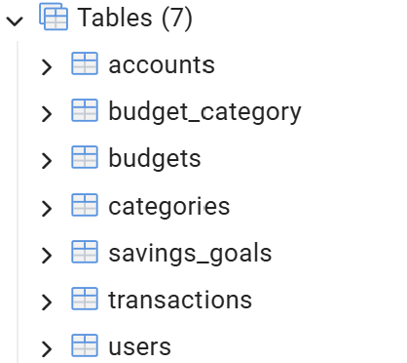
This screenshot from pgAdmin shows the tables created for Fintrack, including users, accounts, categories, transactions, budgets, budget_category, and savings_goals.
Figure 9.7: SQL Query Execution

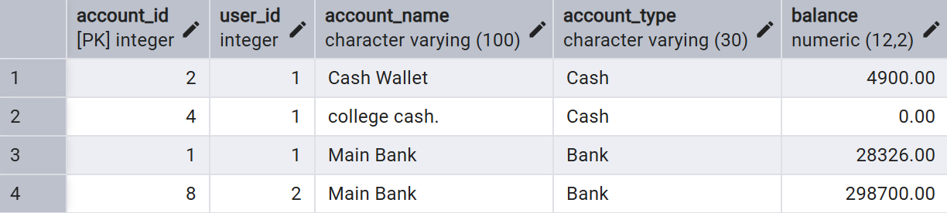
This screenshot demonstrates the execution of an SQL query in PostgreSQL and the results returned from the database.
9.3 Summary
The implemented system demonstrates the integration of a web application with a PostgreSQL database. The application provides the main features of Fintrack, while the database stores related financial information and supports queries for retrieving and summarizing records.
10. CHALLENGES FACED AND SOLUTIONS
During the development of Fintrack, the following challenges were encountered:
- Database Design: Defining relationships between tables was addressed using primary keys, foreign keys, and a junction table.
- Database Connectivity: PostgreSQL connection issues were resolved by checking the database configuration.
- SQL Queries: Joins and aggregate functions were used to calculate income, expenses, and budget summaries.
- Application Integration: Flask API endpoints were connected to the frontend to exchange data.
- Error Handling: Backend errors and invalid inputs were addressed through code corrections and validation.
11. CONCLUSION AND FUTURE ENHANCEMENTS
11.1 Conclusion
Fintrack was developed using Flask, Python, HTML, CSS, JavaScript, and PostgreSQL. It supports account management, income and expense tracking, budget management, and savings goals. The project demonstrates database concepts such as ER modelling, normalization, SQL queries, CRUD operations, and database constraints.
11.2 Future Enhancements
- Add charts and advanced financial reports.
- Improve authentication and security.
- Deploy the application to the cloud.
- Develop a mobile application.
- Optimize database queries for better performance.
REFERENCES
- PostgreSQL Documentation: https://www.postgresql.org/docs/
- Flask Documentation: https://flask.palletsprojects.com/
- Python Documentation: https://docs.python.org/3/
- MDN Web Docs: https://developer.mozilla.org/
- Elmasri, R. and Navathe, S. B., Fundamentals of Database Systems, Pearson.

